**Ajax Lab - Parth Gosar**

File file.html attached.

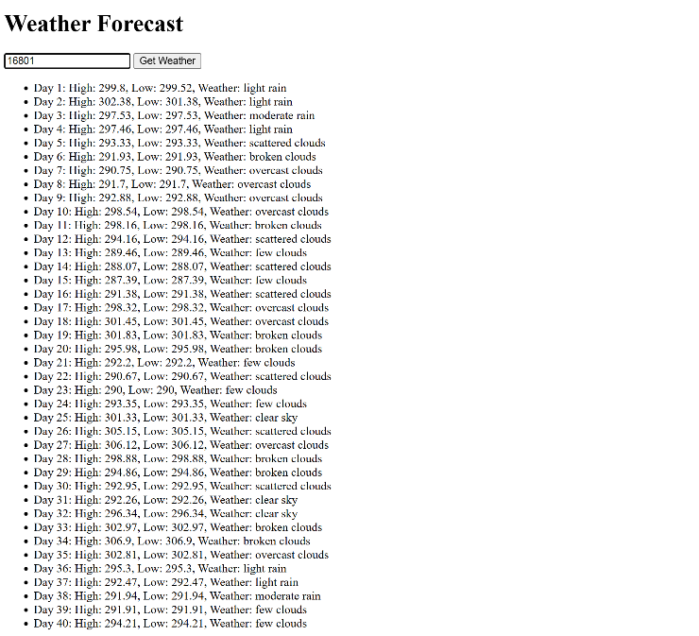Screenshots of different weather forecast



